PRO192- Practice Exam – SU24 13/07/2024
Duration: 85 minutes
Develop an Electricity Bill Management OOP application with the following components and requirements
- Create MVC console application in NetBean:
  - Define class Bill with the following attributes and methods: (1.5 marks)
+ Id (int), customerName (string), amount (double), dueDate (Date).
+ Constructors, get/set(), toString() (in where display the Date attribute in the format “dd/MM/yyyy”).
Note: No IO console is used in this model class
  - Define class ListBill to manage the list of electricity bills has the following methods: (3.0 marks)
+ Read text file to load data for ListBill –Electricitybill.txt is provided (1.0 mark)
+ Method that can add a new bill (check this bill id does not exist in the list is required) (0.5 mark)
+ Method that can delete a Bill by any criteria (0.5 mark)
+ Method that can get a list of unpaid bills (0.5 mark)
+ Method that can get the largest amount of bill (0.5 mark)
Note: No IO console is used in this model class
  - Develop BillManagement class to run the application (4.0 marks)
+ Main menu for application includes: Display all bills, Add a new bill, Delete a bill, Find largest amount bill, List of unpaid bills, Quit (0.5 mark)
Hint: An abstract Menu class is provided for use in the application.
+ Display all electricity bills (0.5 mark)
+ Method for adding new bill from console (0.5 mark)
+ Method for deleting an existing bill by ID, Customer name, or Due date(1.5 mark)
+ Method for finding the largest amount bill in the list (0.5 marks)
+ Method for listing all unpaid bills (0.5 marks)
+ main() method to run the program
Note: This class allows interaction with user IO from the console.
- Technical requirements (1.5 marks):
+ Create a package model for Bill and ListBill class. (0.5 mark)
+ Create package controller and view for Menu and BillManagement class. (0.5 mark)
+ Please handle every exception for adding a new bill function, asking the user to re-enter for incorrect input data. (0.5 mark)
+ User view should be as follows:
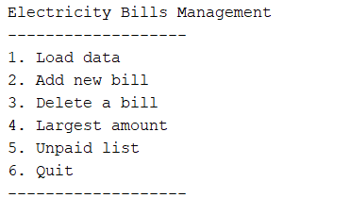
+ The list of bills may look like this:
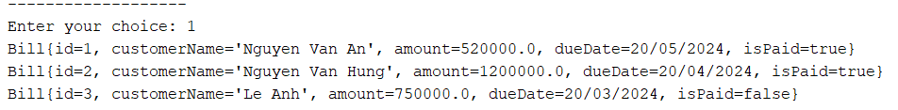
+ Delete menu should be as follows:
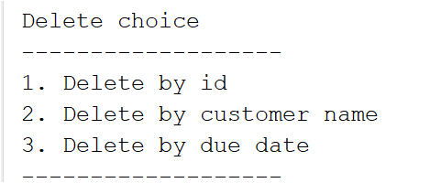
Notice:
- If the student wants to separate view and controller, the student can let the input and output-related methods into the BillView class. In that case, the view package will contain both the Menu and BillView classes.
- Student must strictly follow all requirements as described above for marking,
Any modification of the requirement detail is not allowed and will get no mark!
- Students can use offline material on individual computers and define additional classes/methods for code optimization.

